Art of the Title Lesson 2

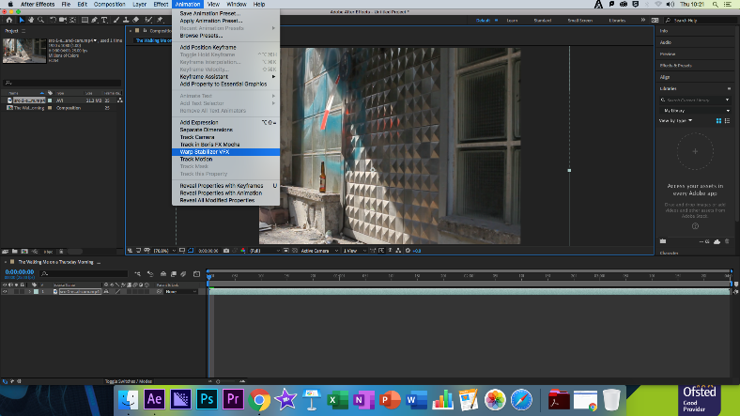
The title sequence we created this week was the opening to the popular television show “The Walking Dead”. With a mild horror background set in a post-apocalyptic America, the Walking Dead takes its inspirations from the comic books bearing the same name. Taking the world by storm when it was released it has since gained a cult following with avid fans defending the shows more recent and weaker seasons with a constant fervour. The show showcases the breakdown of society and human decency as multiple groups vie not just to survive but for power in a broken and lifeless Earth.
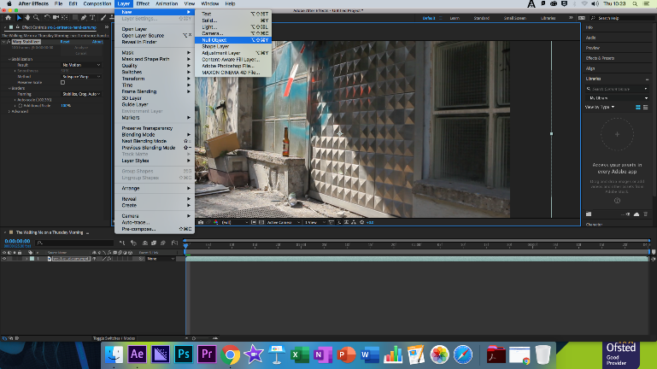
As a class we would be shown how to create the first shot and then use this knowledge to create the rest. Opening I would drag the first clip into Adobe After Effects, this clip however, was blurry, I used the warp stabilize effect to remove this slight shake and add a more eerie, photolike aura to the clip. Using the Warp stabilize effect I changed the stabilization so that there was no motion at all, after this I would add a Null object and then animated it so that the Null objects X position would move one-hundred px over the duration of three seconds, giving an illusion of a camera moving slowly to the left.
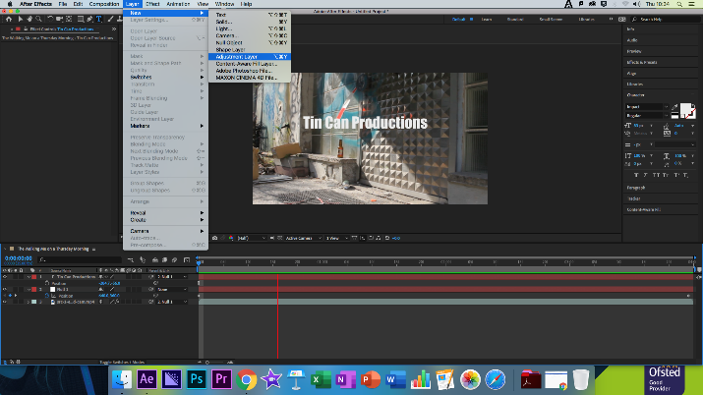
Moving on I would use the Optics Compensation effect to curve the edges of the screen like a fishbowl, I then inverted this so to give the for a distorted look to the footage. I also played around with this to see the extremes the effect could have on the clip, the experiments showed that when used in excess the creepiness of the clip is removed and is replaced by an almost comedic feel. After this I created a blur map within a separate composition. This was done using the ellipse shape tool to create a white solid oval, I then feathered this so that the centre of the shape remained semi-solid, while fading out as it reached the edge of the comp.

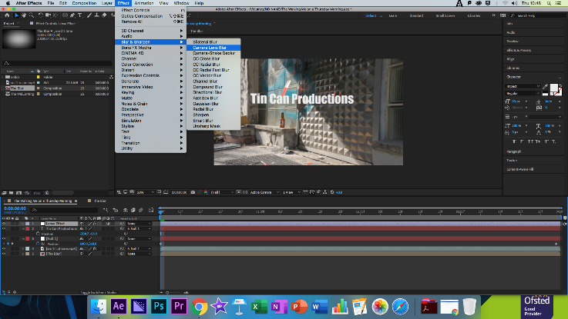
I then moved onto stylising the colour of the clip, giving it a yet more apocalyptic feel. To do this I added an adjustment layer with the Noise and Grain effect, over this I also added the blur to remove some of the more jilted aspects of the Grain. After this I added another adjustment layer, this time with colour correction and a Hue and Saturation effect, using this to lower the images saturation. Finally, I would add a Simple Curves effect to add the final sepia tone to the clip.
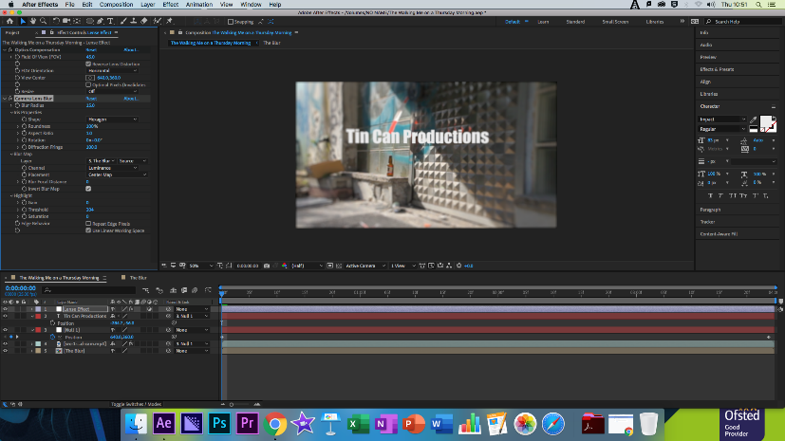

Modes of Persuasion

Ethos: The Walking Dead much like Harry Potter has two large appeals to it, those who read the comic books when they were younger and therefore fans to the source material, also bringing an element of nostalgia to the show, and those who are fans of certain actors within the show itself.

Pathos: Although I have not watched the show as I am not a huge fan of the zombie genre, although I have watch some of the opening sequences on YouTube and they seem to change slightly as the show progresses, this is to reflect the degradation of the world around the characters that the show follows as well as the growing numbers of Zombies that threaten them.

Logos: The logo of the show follows the Pathos and becomes slightly darker over time, hinting that the survival of the shows characters is steadily becoming a bleaker and bleaker prospect as time goes on.

Reflection

What Happened: Using a combination of Motion Tracking, the Warp Stabilization tool and Null Objects I was able to recreate a segment of the Walking Dead opening title sequence.

Feelings: Opening the lesson folder I honestly felt incredibly daunted by the entire procedure, however it actually proved easier to create than the Harry Potter sequence, and the everything I had learned in the previous lesson allowed me to move through this sequence much easier, although I did still get stuck a couple of times.

What was good/bad: Although I do not feel confident with the software as of yet, I feel like I am beginning to understand the basics of it as I progress through the each lesson, I am beginning to overcome my avoidance of title sequence animation as I see its less complicated than I originally first thought.

Analysis: My confidence has grown slightly when using the software but as mentioned earlier I still have a long way to go, A lot of the things I learned in this lesson will help me in building my own title sequence later in the year which I am starting to build up an idea for.

Action Plan: I shall visit YouTube and create some additional versions of the Walking dead opening as well as other tv shows and games, allowing me to further my skills.

Finished Clip: https://www.youtube.com/watch?v=MCkcBGIo5oI

