Art of the Title Lesson 8

This lesson was mainly focused holding keyframes and their usefulness in creating a glitch effect within a title sequence.

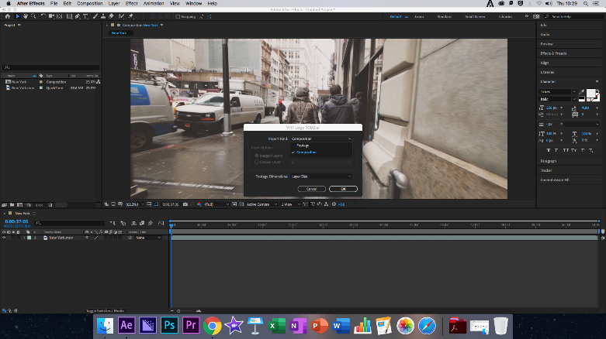
To start we simply took the New York footage and dragged it over the New Composition Button, this created a new composition in under the size and specifications of the already created footage.

We then moved the VH1 logo into the composition as a composition itself, this allowed us to individually move each layer of the logo individually to create the logo’s title Sequence. After this we emptied the VH1 Composition and moved it into the main composition, this allowed us further movement of each segment of the logo within the main New York Composition.

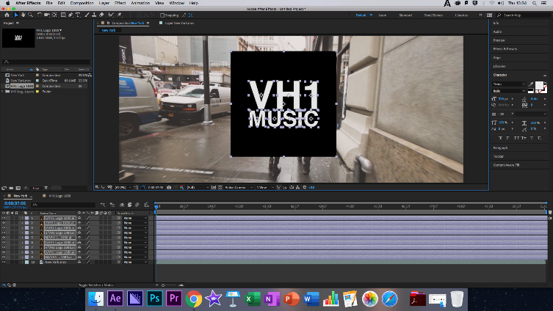
Placing a Keyframe at 0.00.43.20, the location of the end of the Animation, and began creating random movements for each of the logo segments, I personally repeated this step four more times for each segment of the logo. We would then copy and paste the five keyframes twice again for each segment of the logo.

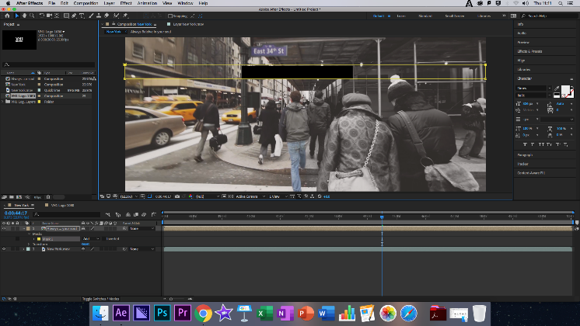
This created a scattered series of animated keyframes, to resolve this issue we selected the keyframes and right click to reveal the Keyframe Manager, selecting the Keyframe Interpolation. Lastly for this section we would select a Hold Keyframe and then Precompose the logo once more finally adding a Mask and copying each Precomposed layer at a time to give a glitched look and feel to the Title Sequence.

Modes of Persuasion

Ethos: VH1 is clearly a music-based company and displays it modern style with a sleek, stylish logo, although I do not know much about VH1 as I have never heard to them so cannot comment too much on their Ethos. VH1 could attract fans of more modern music with it style reflective of the modern rap scene, moving some from MTV which is now a dated Music station.

Pathos: VH1 is a celebration of modern music’s, as referred to above it connects to a younger audience and is clearly marketed this way for obvious reasons, as younger audiences are more likely to consume music from a wider variety of sources than those of older generations are likely too.

Logos: Trailing Loyally behind the Pathos as always. The Logos of VH1 is clearly to show a wide variety of music from artists in the modern age, attracting younger audiences who this music is aimed at.

Reflection

What Happened: This week we learned how to use different forms of keyframes, up until this point the most advanced keyframes we had used were the easy ease or Bezier Keyframes, this is so that we have a wider variety of keyframes at our disposal.

Feelings: I felt very good about this week, the new keyframes where easy to understand although I got a little stuck I managed to quickly correct my mistakes, I even remembered many of the locations of the items that we would need to use throughout to creation of the title sequence, a far cry from how I felt last week, this week again I could feel my progression and this increased my mood tenfold, I feel a lot happier moving on than I did a week ago. I also feel more excited to see what I will be creating next week.

What was good/bad: This week nothing much went wrong, I was able to follow the steps with a decent level of competence and didn’t need to ask for much help, I missed a small segment of the lesson when required to talk about some of the things within the previous days student rep meetings but was able to catch up quickly.

Analysis: This week shows that last week may well have been a blip on my radar for how I acted during that lesson, the difficulties I faced feel more like a small inconvenience and I was having a bad day, rather than a regression of my skillset within Adobe After Effects.

Action Plan: As always, my action plan is to practice outside of class and revise the topic with online sources such as Adobe specialised YouTube Channels.

Finished Clip: https://www.youtube.com/watch?v=E-eh40Tp7Iw

