Art of the Title Lesson 10

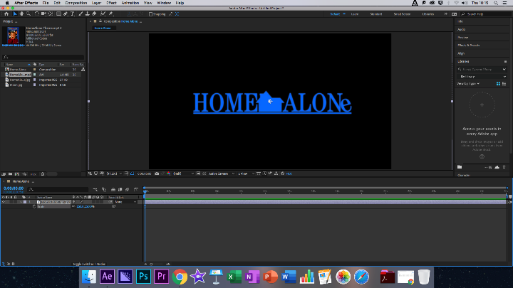
This week’s lesson was based upon the Home Alone title sequence, a popular Christmas film that releases on the 7th of December 1990 and became a classic almost instantly, finding its place on prime time tv every Christmas.

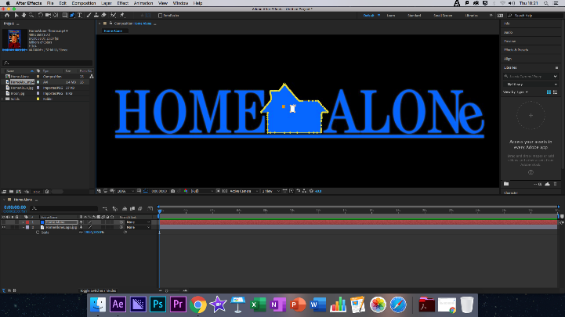
To begin we created a composition that was around 10 seconds long using the regular settings, although I accidently set mine to 30 seconds, but this did not affect the composition too much.

Firstly we imported the lesson folder into the composition and used the logo as a base, making around it and adding a solid layer, using the Colour Picker tool we then matched the exact shade of blue from the original logo, this ensured that the new logo would look almost identical, although I decided to make some small changes to mine, using a less clean cut font and giving the house a more rough edged appearance. This process was semi repeated for the window although it was cleared, and the colour was not copied.

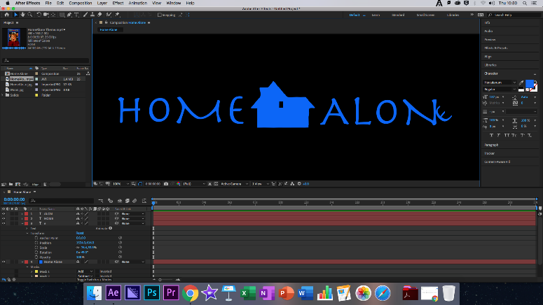
Next it came to insert the text, this was done in three separate parts, the first was the word home and the second Alon, with the E being placed separately so that is could be made to lay on its side. At this point make sure all objects are 3D and then add a Null Object and then a Camera.

Once this is completed, we set the X, Y and Z coordinates to specific key frames at 0 and 3 seconds. Once this is done, we went back to the beginning of the composition and moved the camera to the top right of the composition, adding the moon from the lesson folder, at this point we could create our own clouds or could take some royalty free ones from google, this was the choice I made, I made the moon and the clouds 3D and moved them in place, allowing the animation to move freely.

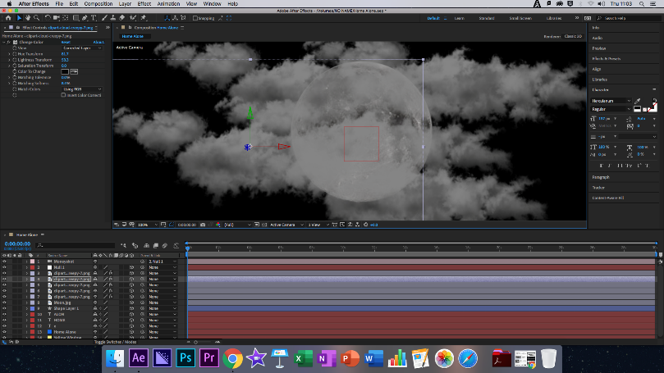
You’ll now add another Solid Layer and make it a shade of yellow, this will become the light in the house, we moved this to 7 Seconds in the composition to the lights come on in time with the title. After this add another key frame and zoom the camera out, turning each keyframe into and easy ease keyframe.

Finally, we key framed the actual title to slide in on both sides of the house at the 7 seconds and 7 seconds 10 frames segments of the composition to complete it.

Modes of Persuasion

Ethos: Home Alone is a Christmas classic playing on the age-old fear that every child faces the first time they find themselves home alone. The film succeeds in taking a serious scenario and placing a young boy up against two potentially dangerous individuals. As a family film it can bring in a large audience, ensuring that the film can also become timeless as future generations by re-releases for their own children.

Pathos: The film is a fast paced flick which keeps running once it gets going, although later instalments felt serious franchise fatigue the same aura and style of the first film was kept as a serious situation shown in a more friendly setting, a clever twist Hollywood would come to repeat many times over.

Logos: As always the Logos follows the pathos, with a clean cut logo the film shows of its mature setting, with the comical light flash showing off the solitude of the film whilst the flashy movements and music show off the funnier side of the film.

Reflection

What Happened: Today we re-created the Home Along title sequence, it was easier than most of the previous title sequences but still presented its challenges.

Feelings: I felt very well equipped within this lesson, and was able to take on most of the title sequence with ease and this was the first lesson in which I did not have to ask for help for anything as I was able to find most of the items I needed as soon as they went up on the board, even adding my own flavour to the title. I came away felling positive with the result of the exercise.

What was good/bad: I didn’t feel anything really went badly within this lesson, I even diverged from the recommended creative path slightly as I’ve started to find ways of doing things ain After Effects that are easier for me overall and the black cloud I experienced at the start of the first lessons seems to have all but faded at this point.

Analysis: Not only do I now have a firmer grasp with aftereffects, but I am confident enough to take my own path down the creative path and use shortcuts that allow me to use the software more efficiently. This helps me greatly as a creator as the editing process is not my favourite and feeling like I can use the software my own way is important for me to reach the best of my creative abilities.

Action Plan: I am beginning work on my own title sequences now for my own production company as well as my FMP.

Finished Clip: https://www.youtube.com/watch?v=DG0e_dBB5ps

