Art of the Title Lesson 5

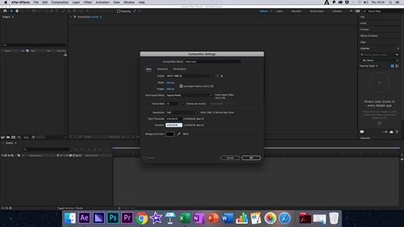
In this lesson we re-created the logo for intel, using the same base as the custom scary room title sequence. Tis Logo/title sequence has become one of the most recognisable brands in modern, western society, with almost everyone knowing what Intel is.

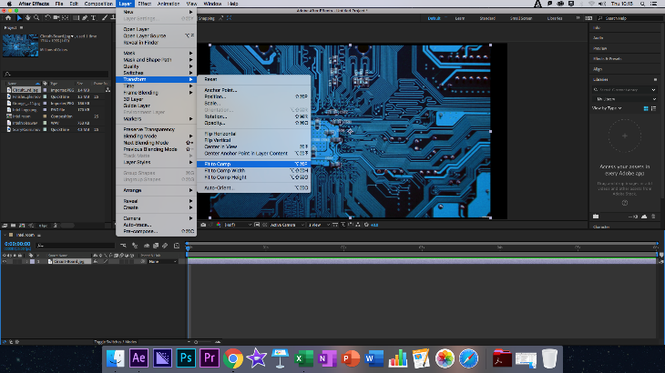
To begin we create the composition, this is HDTV 25, 1920 x 1080 as always, and we switch this to around 30 seconds long, taking the circuits image we placed this neatly on the composition, then we simply fit to comp to allow the image to fill the screen.

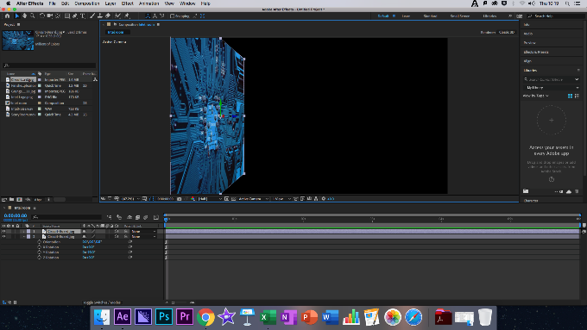
Next, we made the object 3D which allowed us to rotate it on its Z axis 90 degrees, we would then move the panel to the left on the Z axis, then repeating these four more times to create a small corridor.

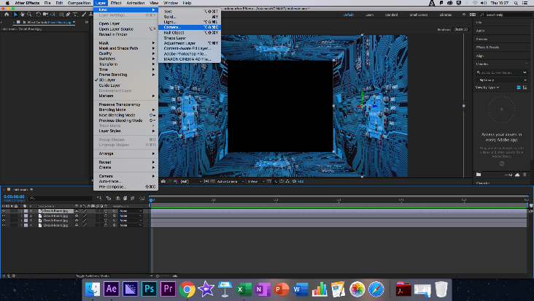
Once this was completed, we created a new camera, to do this we added a new layer and selected camera, then set it to the 35mm pre-set, centring the box as we did. We then too the circuit image again and placed it into the composition, making it 3d and pushing it back so that it fit into the hallway which we elongated just before the placement of the final piece.

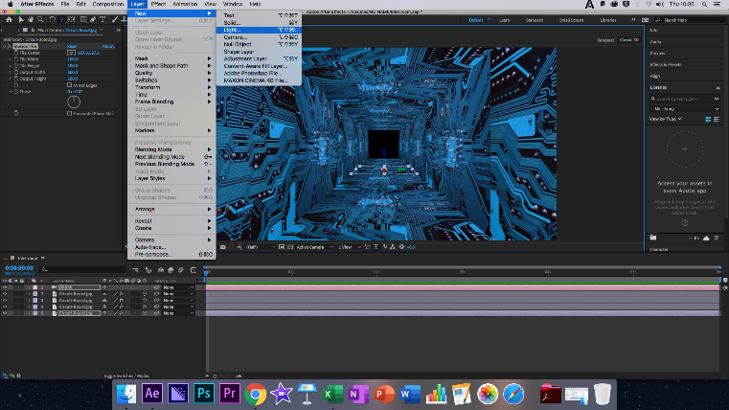
After this we add a Light Layer to light up the corridor in a way we wanted, I chose a red colour as this has become a sort of thematic pattern I have begun using. I changed the intensity to three-hundred-and-fifty, making the colour of the light red, I would then have to darken the back panel as it stood out from the rest of the composition. To fix this, I went into Colour Correction and selected Exposure, lowering this to match the colouration of the end of the corridor.

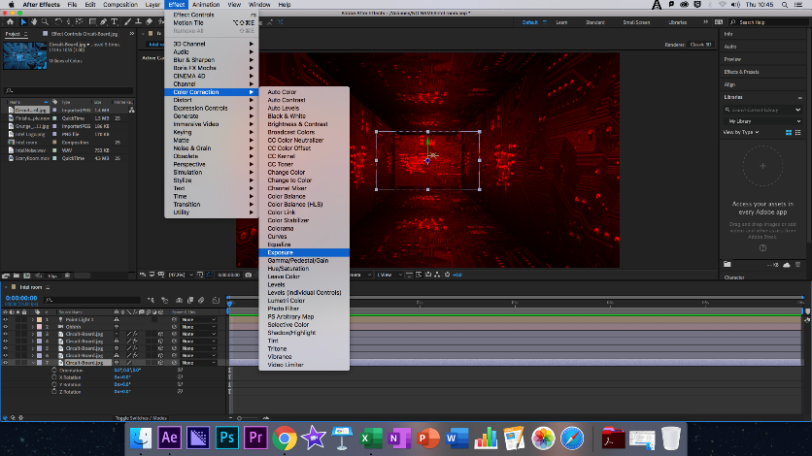
The class then moved onto using the Motion Tile Effect, changing the Output Width to 500 and to increase the length of the wall even further. We then copy and pasted this to both walls, ceiling and floor, to ensure this was evenly distributed, moving the end layer back again yet further and adjusting its exposure to correspond.

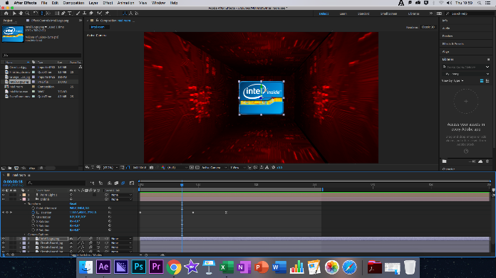
We then added the intel logo, this turned red when we turned it into a 3D object, it turned red along with the red of the composition, this needed to be fixed, selecting colour correction once again and turning off Allow Colours whilst ensuring that the logo was set above the light layer.

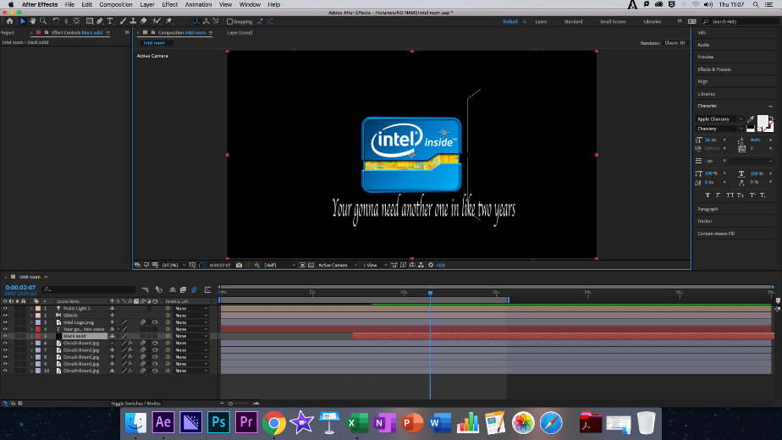
Here I had some issues, as the class added keyframes to move the camera into its set positions to give the look of motion, my animation jumped back and forth, however this was simply solved by an Easy Ease keyframe. Finally we used a black Solid Layer faded in to give the impression only the logo was left, with a small piece of text underneath, I then added in some Windows sound effects and another black Solid Layer for a final fade to black as a personal touch.

Modes of Persuasion

Ethos: Intel is a computer hardware/software company that has existed for many years in the digital age and is responsible for many of the great leaps forward in computing technology over recent years. It intel core processers have been designed for gaming, editing and business, giving them a wide range of customers and a loyal fan base of people who use their products.

Pathos: As stated above, Intel is a major company in the computing field, with their processors being used to supplement the Windows operating system for many years, allowing it to become the giant that it is. With its large versatility it is clear that Intel is designed for innovation and continues to bring forward more powerful processors for public and business use.

Logos: The logo of Intel is simplistic yet artistic, giving the consumer a good idea of what they are buying into with Intel, a sleek and professional experience, but also a creative one, for those who wish to game, or even edit their own Title sequence, the logo shows off Intel’s variation within their products.

Reflection

Feelings: This week felt much easier than weeks prior, I have been noticing I feel less lethargic coming into a title sequence lesson than I did five weeks ago, I only had one major problem to tackle and it did not daunt me as much as it had in earlier lessons, with a small amount of help from Ollie I was able to understand the issue and learn how to fix it in future, I feel satisfied with the lesson.

What was good/bad: The lesson began quickly and we jumped straight into the title sequence, I understood where almost everything was and was able to grasp the creation of the title sequence with little to no guidance for the most part, although as stated earlier I had one minor issue with the camera in which is seemed to bounce backwards and forwards whilst in motion, but was easily fixed with an Easy Ease keyframe and was then successfully animated.

Analysis: I have Begun to feel relatively confident with the software now, although I am nervous for the test and do not feel entirely ready to go it alone, I am confident enough to experiment more when creating these title sequences in lesson, as can be seen with the different style of lighting and audio I have used to create the finished project.

Action Plan: My action plan has not altered too much, although I really want to begin practising and experimenting with title sequences from shows I love, such as Doctor Who, I did not feel a need to touch After Effects whilst at home before but now have more of an itch in which I want to actively try new things, I plan to act on this mostly over half term when I will have more free time to do such experimentation.

Finished Title Sequence: https://www.youtube.com/watch?v=a9-DTX4mNvk

