Art of the Title Lesson 3

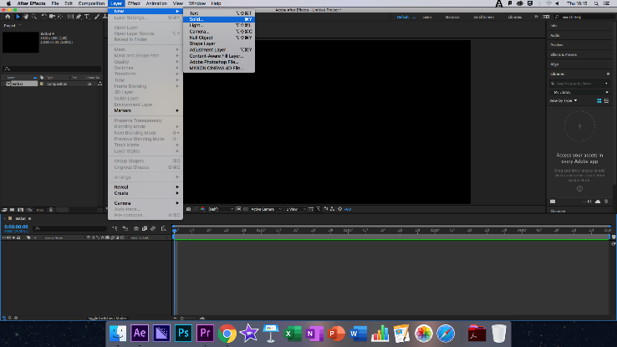
The Title Sequence that we created in this lesson was based upon the opening of the Dark Knight Trilogy. The Dark Knight is the famous Christopher Nolan Trilogy of Batman films that rebuilt the character of Batman, bringing him back to his darker roots in the DC comics Universe. Most fans will agree these films gave the best portrayal of the character to date with interesting plotlines and a balance of power taking place in Batman’s very mind.

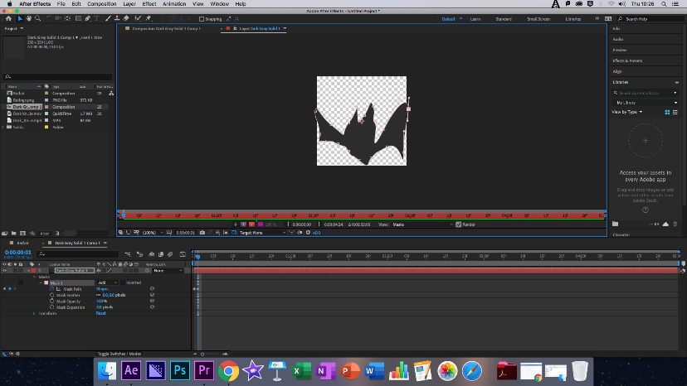
To start this Title Sequence, we would create a main composition as usual, this would give us the basis of the title Sequence. Next, we would create two black layers, the first would be the same size as the composition (1920 X 1080) the second however would be 250 X 250. This second layer would be used to create the animated Bats for the Title Sequence.

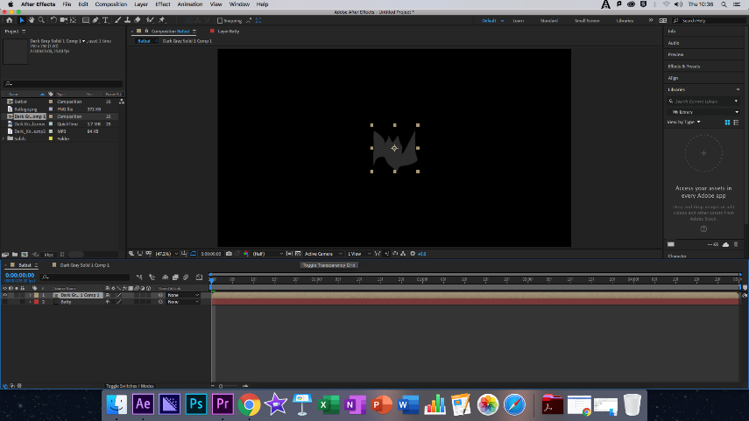
To do this the class would pre-compose the smaller layer and use the pen tool to draw out a rough bat shape. Using the Mask path we set a Keyframe at 0 Seconds, and then moved the Bats wings, this eventually created the appearance of the bat flapping its wings, once this was done we copied the animation and allowed the bats to fly for the full Title Sequence.

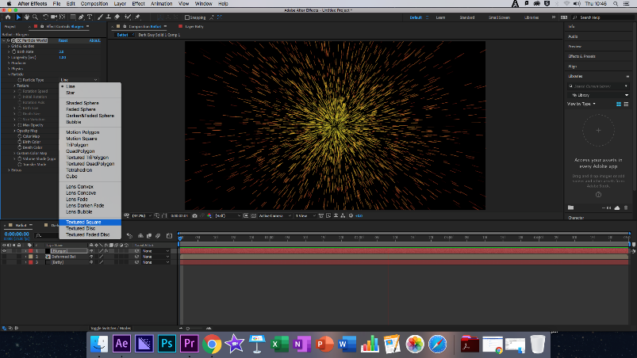
Returning to the main composition we installed a transparent background and turned off both the smaller and the background layers, then proceeded to ass another black layer, again the same size as the main composition. At this point we added the Particle System using CC Particle World and changing its gravity to zero. After this we changed the particle type to Textured Square and then connected this to the smaller layer, turning the particles into small bats, changing the texture time to begin at the start of the composition, this allowed for each bat to fly individually.

Next we increased the Death Size of the bats and keyframed the birth-rate of the bats so that their was more of them on screen over time. After this we brought the Batlogo into the composition, again turning off the background for a transparent layer, scaling down the Batlogo to fit the composition, this was done with action safe on.

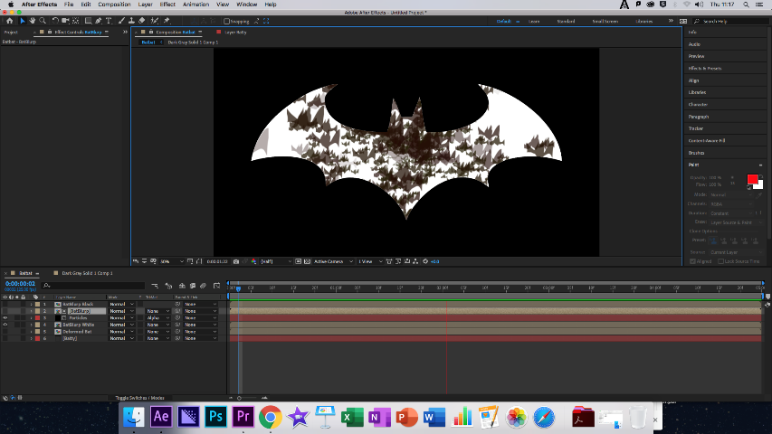
The Batlogo was then pre-composed and three different versions of this where created, the original, Black and White. On the white composition we used the invert effect to turn the logo white. Black was then turned off and the track matte of the particles layer was connected to the original with Alpha Matte, causing the tiny flying Bats to be produced within the Batlogo. We then removed the white fringe from the white Batlogo using the Simple Choker effect set to three.

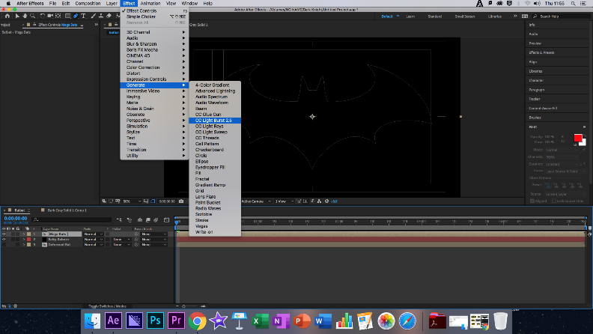
Turning off all the other layers we then used the pen tool to draw around an abstract around the Black Batlogo, once again using the Mask we set a key frame at zero seconds and increased the expansion so that the Batlogo was once again complete, using key frames we then reversed this so that the Batlogo appeared and disappeared throughout the composition.

Moving forward we used the effect CC Light Burst 2.5 to give the impression that the Batlogo has light bursting forth from within it. To complete this effect, we then increased the Ray Length to 180, causing a god ray effect, then quartering our resolution so that the Mac could continue to render the project.

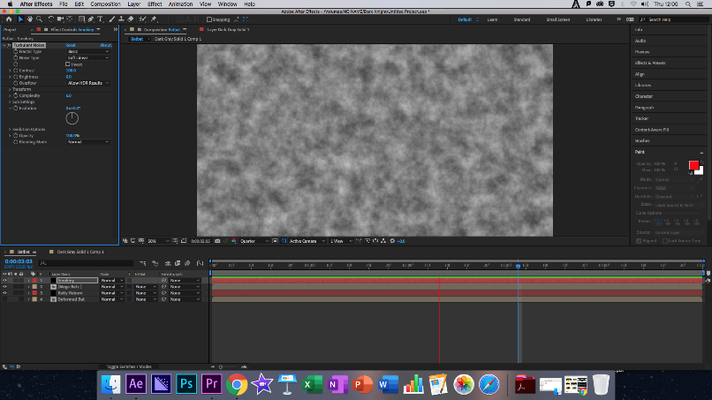
Once again we added a new layer the same size as the main composition, adding the Turbulent Noise Effect, this layer was called Smoke. Changing the Fractal Type to Dynamic Progressive gave a thick smoky effect across the screen. We then increased the Contrast of the smoke to four hundred and the Brightness to seventeen, eventually changing the scale from within Transform to one hundred and fifty-six. Once again keyframing so that the smoke gave the impression of movement, with an Evolution Value of two.

We then created a duplicate of the main title composition, Naming one Smoke and the other Glow. We then had to ensure that the Smoke layer was above the Main Title – Smoke and changed the track mode to Luma Matte, connecting with Main Title – Smoke.

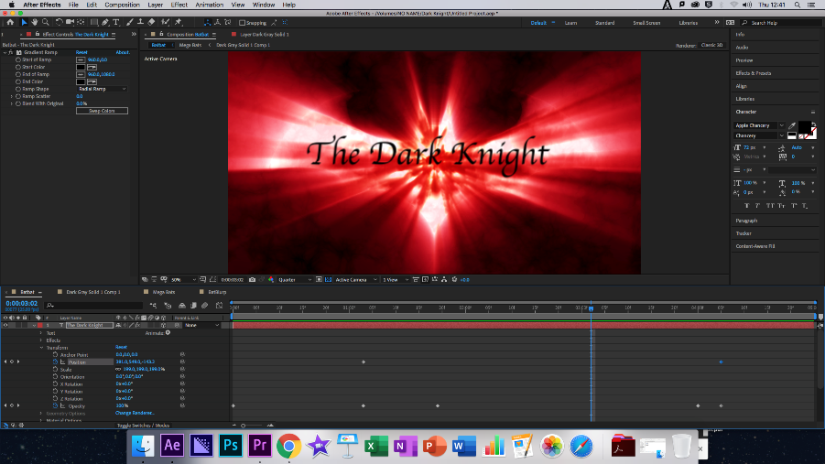
Selecting Main Title – Glow we deleted the Light Burst Effect and added in Glow, adjusting its Radius and Intensity to create an individual look. Now we created an adjustment layer, adding the curves effect to create a colour of our choice for the Title Sequence. Finally, we added the text, giving it a 3D effect so that the text would move along the Z access towards the screen, finally keyframing it so the text appeared and disappeared accordingly.

Modes of Persuasion

Ethos: Similar to the previous two franchises the Dark Knight has two major appeals, the rich nostalgic fanbase of the property and also those attracted by the actors who starred in the films.

Pathos: The Dark Knight films are some of my favourite superhero movies, although not a massive fan of DC films. This has allowed me to witness the steady transition of the Dark Knight title sequences, although these are very minor as the Batman films are dark from the beginning and the themes rarely change, with the exception of the franchise being its finally, with Batman having to overcome his greatest obstacles and eventually reaching his final form.

Logos: The logos follows the Pathos loyally as it always does, show casing what to expect from the Dark Knight films within the first five seconds of each movie.

Reflection

What Happened: Using a combination of various effects, layers and the pen too, I was able to create my own rendition of the Dark Knight opening.

Feelings: I had mostly positive feelings throughout this lesson, although a lot went wrong, I found this the easiest Title Sequence to create and the one I felt most connection with, as I grew up with these films. I also had the most fun creating this Title Sequence, from drawing the bats to adding the famed Dark Knight theme music.

What was good/bad: I was later getting into lesson on this occasion and found myself lagging slightly behind, having to catch up and follow the steps quicker, however I managed to catch up and was drawing the bats with my contemporaries in no time. I would later copy the wrong layer and cause issues with my composition although this was rectified with help from classmates.

Analysis: This lesson has allowed me to feel far more confident when using After Effects and I look forward to the next lesson, I still have a while to go before I am proficient but this lesson was a turn around with me even experimenting and placing my own twists on the Batlogo.

Action Plan: I shall revisit this Title sequence again for future use as its interesting and could be useful for my own FMP.

Finished Clip: https://www.youtube.com/watch?v=CpWq13jHyUg

