Art of the Title Lesson 6

This lesson focused primarily on creating 3D objects within Cinema 4D and getting them to react within the Adobe After Effects Software. Previously we had only been working with 2.5D objects as these are what easily available within Adobe After Effects.

To start with we imported the piece of footage called tracks into Adobe After Effects, however, for the footage to fit correctly we needed to drag the footage over the new composition button, allowing us to create a composition based around the clip itself.

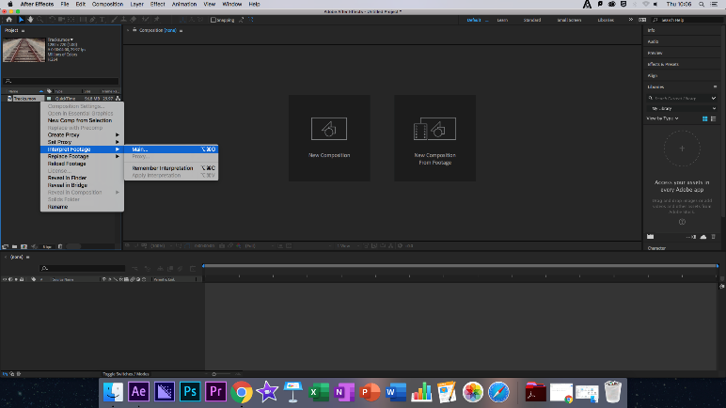
After this we had to ensure that the frame rate matched up with the default FPs of Cinema 4D (30FPS) To do this we simply right clicked on the footage and used the Interpret Footage – Main tool and increased the FPS to thirty, we would then track the camera, this would take some time for the software to analyse and prepare the clip.

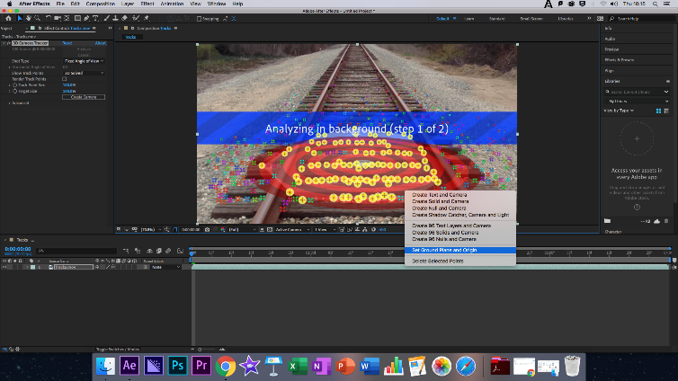
The next step was to click and hold the left mouse to draw a circle, we then right clicked the circle and selected Set Ground Plane and Origin, although was had to guess that this had been completed as there is not indicator for this. Right clicking once more we had to Create Solid and Camera, this would create a 2D solid Layer that was tracked by After Effects.
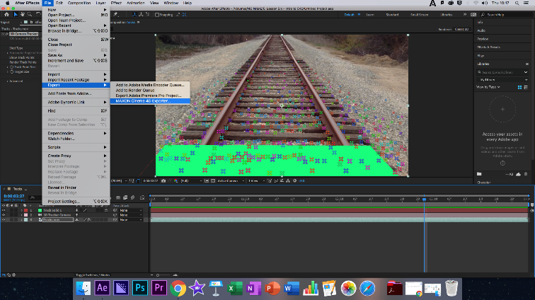
With the Solid Reference in place, we Exported the file to Maxon Cinema4D Exporter. Directly after this we took the newly created C4D file and imported it into After Effects, dragging it to the top of the timeline, then selecting the file and choosing Edit Original, opening Cinema 4D Lite.

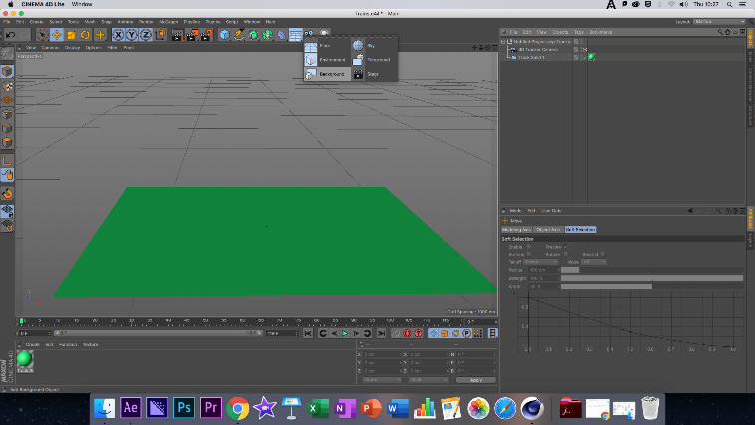
The next point of focus was creating a background layer within Cinema 4D, to do this, we selected the Floor Option, and clicked on Background, with the Background in place it was time to place the background material, to do this we simply used Material Manager and selected New Material. Double clicking on the new Material allowed us to view its properties, within this was the colour panel, we used to load in the clip we was using in After Effects and which gave us a better idea how the 3D animation would look in After Effects. With the new Material created we dragged it over the background layer to apply it to the animation. Finally, we had to turn Animation on for the background to move.

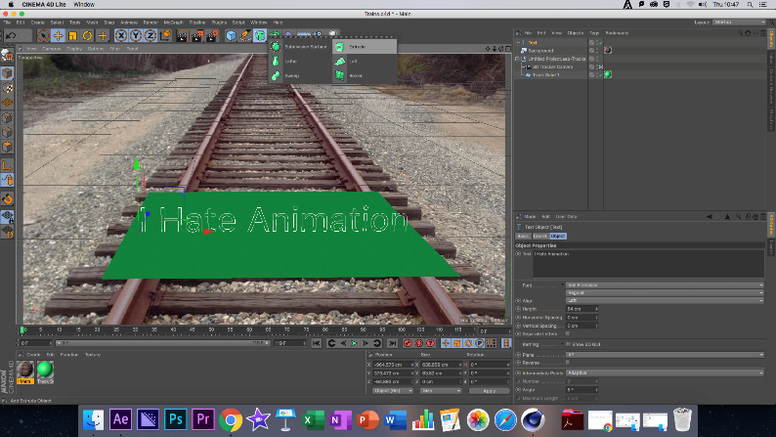
After this we added the text, using the X, Y and Z axis to position the text where we wanted to locate it. Next, we had to extrude the text, using the option located at the top of Cinema 4D called, Extrude Nerbs. After this we dragged the Text Spline into the Object Manager and waited for a downward Arrow to appear, linking the two, the created text was not very pleasing to the eye, by using the options within Extrude Nerb we selected Caps which allowed us to mildly change the shape of the text to one we found more smooth and pleasing. We then quickly rendered the scene.

Once again, we created a new Material, to simply give the text colour and repeated the earlier Material process. After this we deleted the Track Solid and began to light the animation, to do this we simply selected Light from the top to the screen, specifically the Omni Light. Once we had our light, we positioned it using the same system as the text, once we had saved the light, we saved the project and repeated these two more times for the other two lights, quickly checking in After Effects to see if the project had updated.

Finally, we rendered the project as normal.

Modes of Persuasion

Ethos: There wasn’t a huge amount of Ethos for this week’s lesson as it was more the teaching of a skill rather than an actual title sequence, although these skills will be incredibly important in the future whilst using 3D shapes within After Effects.

Pathos: There was also a lack of pathos, due to the reasons stated above in Ethos.

Logos: As logos follows pathos, there was no real logos, other than the style of the text that we each individually chose, this could be a sign of our individual personalities and creative minds, which could be an interesting look at personal human psychology, as in a way, what the text said and how it ended up looking would reflect upon us as creators.

Reflection

Feelings: This week was challenging, my more outgoing attitude towards after effects quickly fell to the wayside as I found myself struggling in a new dimension, at times staring the computer screen in a blind sense of panic and confusion, although the steps where easy to follow, they where in some cases troublesome to carry out, this is purely due to another software being introduced. With the basic grips of After Effect being understood by oneself, it did not entirely daunt me upon applying what we were being taught during the lesson.

What was good/bad: Overall the lesson was an intriguing one, although something I really had trouble with was the lighting. I kept forgetting to render and this caused me to believe that the lighting was not working, the other issue was that the lighting simply did not do what I wanted it to, although with a bit of help from Ollie, I gained a mild understanding of how the lighting system worked and had a small amount of experimentation.

Analysis: This lesson, in my eyes, shows how my attitude has changed towards animation and title sequences, since college I have had a serious desire to avoid animation in any form, this simply comes from my inability to draw. Whilst I can craft entire universes with words, my artistic gifts do not entire into the world of drawing, so when faced with After Effects, a mild feeling of panic fell over me, and made me begrudging to learn, however, I had a rough knowledge of how to create models thank to my animation lecturer in year one pushing me to use Blender, so I wasn’t entirely phased. Finally, opening Cinema 4D scared me but I felt more inclined to hit the ground hard and keep running, for me this was far more a look at my own progress, not just within a skillset, but also my willingness to learn said skill set, all of this is ironic however as the first film based job I wanted when I was younger was to be an animator.

Action Plan: as with the las few lessons I have searched for further tutorials and drawn up ideas for Title Sequences for my end of year show, as well as practising within my free time.

Finished Title Sequence: https://www.youtube.com/watch?v=8z19RyYWaWw

