Costumes:

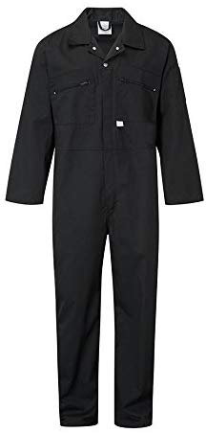
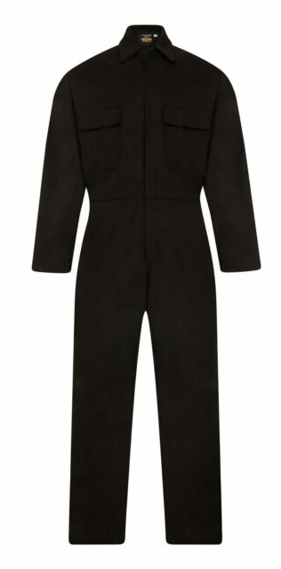
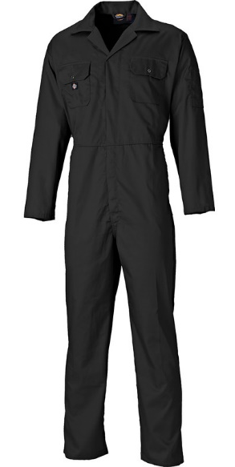
There will only be one style of Costume that will be used within the project, this will be black overall, inspired by the clothing warn by Allied Soldiers in both World Wars, this simplistic colour scheme was easy to produce and helped the allied war effort greatly, the idea behind the black overalls is that a rebellious force would also choose a simple and easy to produce uniform for its fighting forces. The black colouration is taken from the spy heritage of the three main characters, showing they are a special operations unit, a small Union Jack Patch will be sown onto their left shoulders, to show they are fighting for the Free Government of Great Britain.

Peer Review:

After showing off the idea to fellow class members they gave their advice on what to improve and what they liked about the idea.

- The Expanded Universe should not be the focus.
- I like the story.
- Beware of the scope and scale of the project.
- Similarities to other war films could be risky.
- Idea of worst possible outcome of post Brexit interesting.
- Ideas warrants warnings as film could be seen to be too right wing, lowering viewership.
- Research seems in-depth and reliable.

