Primary Research:

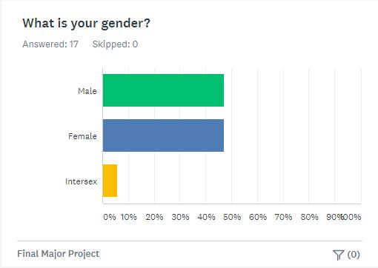
A Survey was undertaken with male and female participants being represented equally, with the largest age group who participated being around the age of 18 to 24, with a few participants being aged 25 – 34.

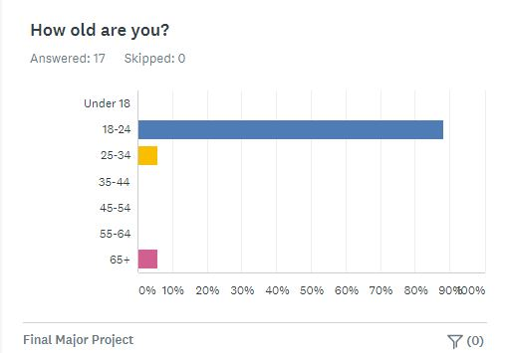
This is incredibly important as it shows how effective the ideas put forward within the film, however we were unfortunately unable to obtain much information from the the older demographics we were looking for.

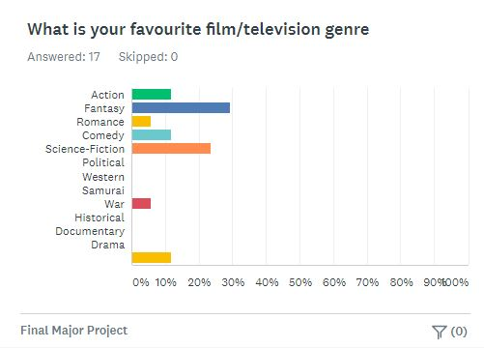
The winning factor for the collective favourite genre was tightly fought between Fantasy and Science-Fiction, with war actually receiving very minimal support, this shows that among who were asked, there is a very niche demographic for war films, although success of films like Dunkirk show that they can be successful.

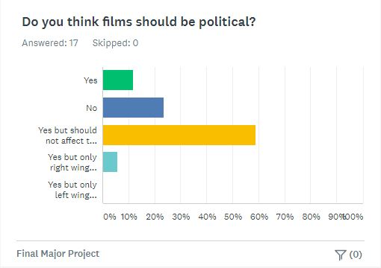
As the project has a heavily political theme, the survey group where asked if films should be political, a very minor group stated yes, but with only right-wing films, this minority will be ignored as it will not carry weight with a wider audience. A slightly larger group stated that it should, whilst the second largest claimed it should not be put onto the screen. The majority however agreed that politics had a place within media but should not affect the plot or quality of the product produced.

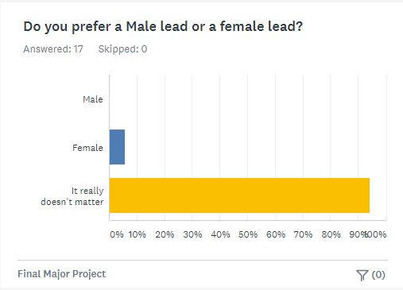
To gauge what style of lead protagonist the audience would receive best it was asked whether a male or female lead was preferable, with a resounding majority stating that it does not matter which gender a lead character has.

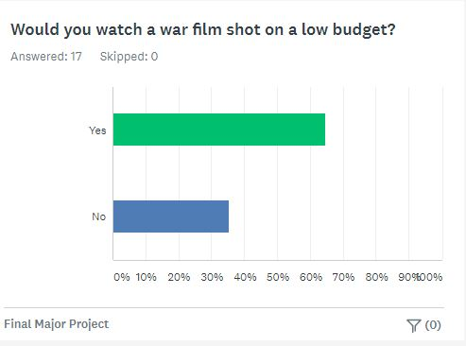
Finally, the survey group was asked if they would watch a low budget war film. Whilst a majority said yes, a large 35% said no, which again sheds some worries over the overall reach of the project.

Secondary Research:

The main source used for the research accompanying the power point comes from the movie Bushwick, the main inspiration for æðelboren. Although not a massive commercial success (Box Office Mojo, 2019) bringing in around $79,888 worldwide, Bushwick tries out many new concepts and relies heavily on a one-take style. Although Bushwick is not actually one shot, it uses clever editing to give that appearance, this look helps keep the film moving. This could be used within æðelboren, although other cuts may be used due to time constraints and the different flow of the film.

The main plot of Bushwick follows an Army Veteran looking wife and child, although as the film progresses it is revealed that they are already dead, and a young woman, looking for her grandmother and sister (IMDb, 2019). The pair find themselves embroiled in the beginning of the second American Civil War, desperately working their way through alleyways to escape the apocalyptic scenario (IMDb, 2019).

Bushwick was nominated for multiple awards at the Neuchâtel International Fantastic Film Festival and the Catalonian International Film Festival (IMDb, 2019), showing the creative splendour of the film and its addition to the art of film.

Moving back to the editing, one of the best at the craft is Edgar Wright, looking at his transitions in the film Scott pilgrim we see more seamless edits, although these are done almost entirely during the editing process, but they set the pace and tone of the film perfectly, mush like the editing in Bushwick (Youtube.com, 2019).

Location Scouting/Test Footage:

Three Locations where considered for æðelboren, the first being Epping Forest, the largest forest within Essex, this is the ideal location to film as it has an incredibly thick woodland aesthetic, however the distance between the location and potential cast and crew is just too great to make it viable option for the project.

The Second was Belfair’s Woods, considerably smaller than Epping Forest, Belfair’s boast open spaces as well as woodland and would suit the script incredibly well, but it is also a well public space, used by small clubs and groups as well as the general public, making it harder to shoot a fast paced war pilot.

Finally, it was settled that Hockley Woods would be the most suitable, in the middle of the size range between Epping and Belfair’s and not as widely used by the public other than the occasional Dog Walker, giving the crew and the cast the space to perform to the best of their abilities whilst also fitting in well with the script, a goldilocks location if you will.

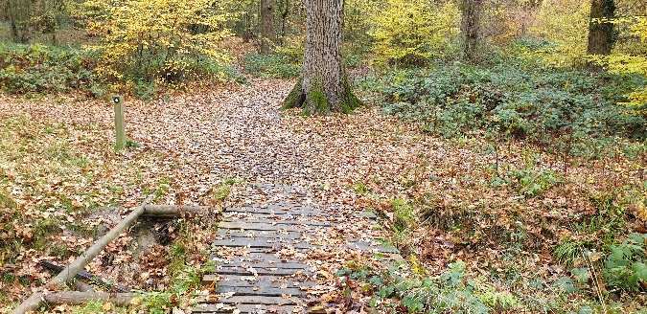
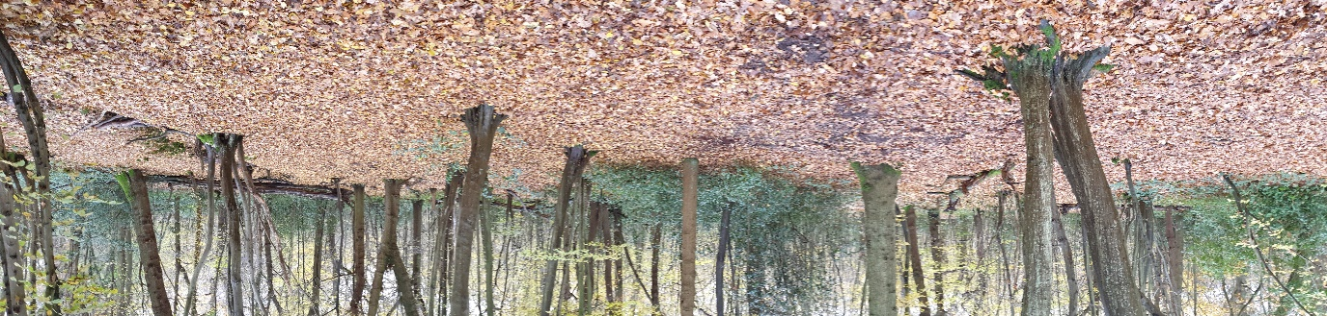
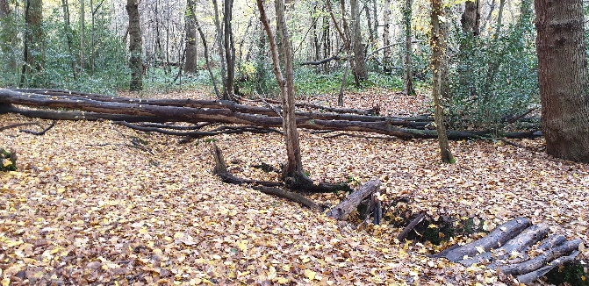
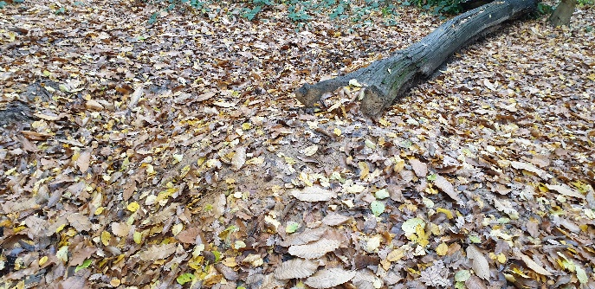
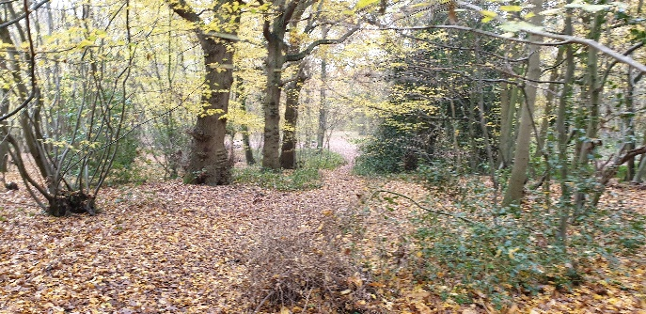
Bellow is some of the images taken from the Scouting trip to Hockley Woods along with a link to the test footage taken on the same day.
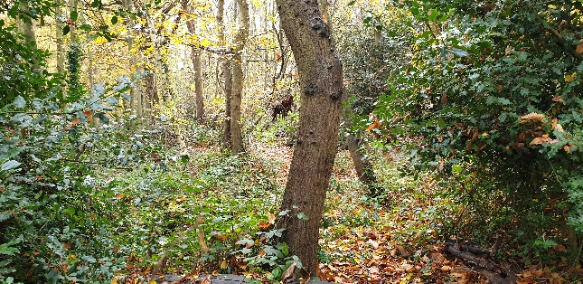
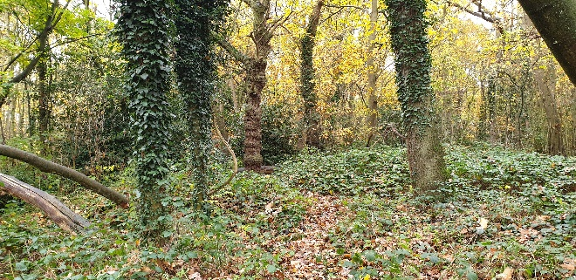
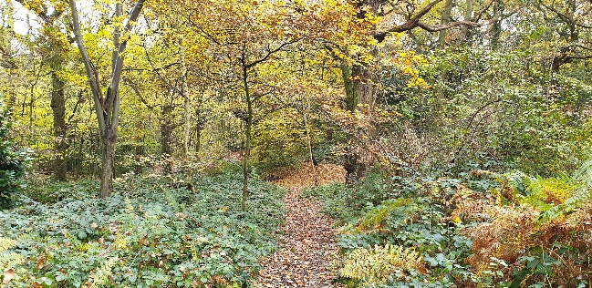
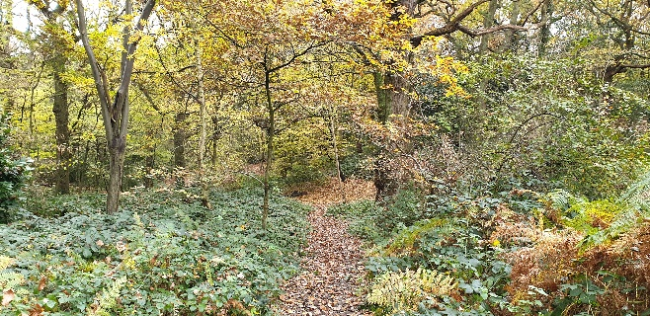
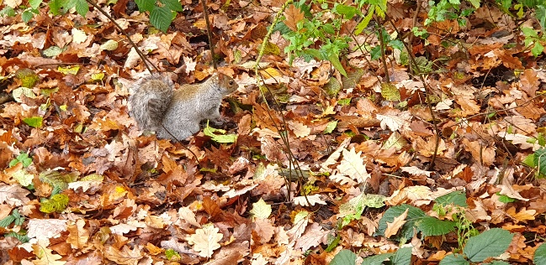
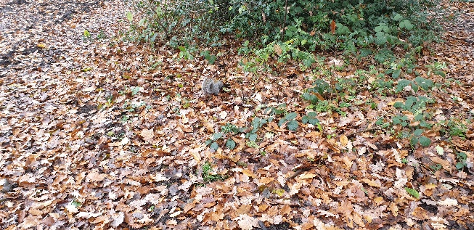
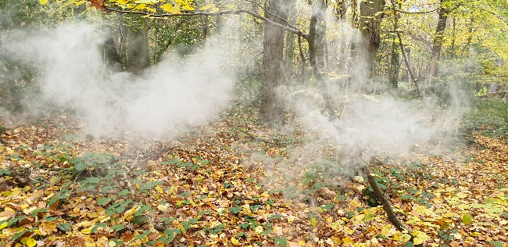
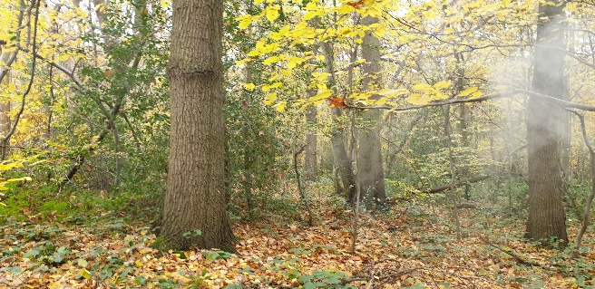
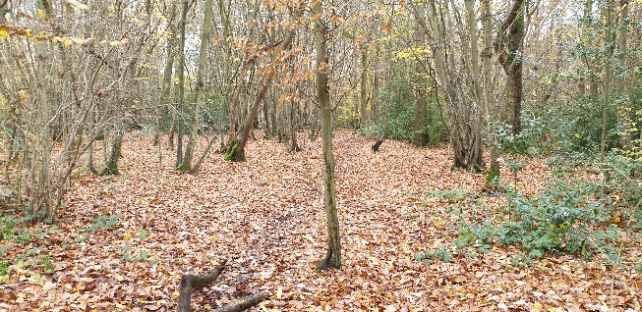
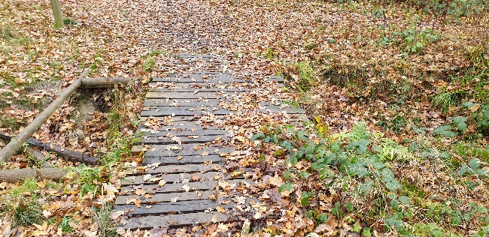
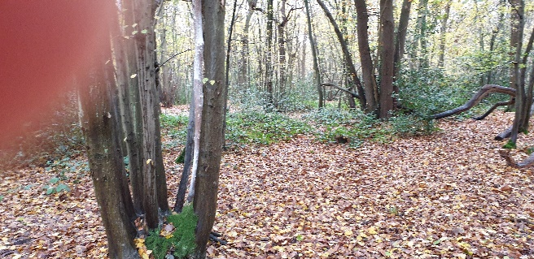
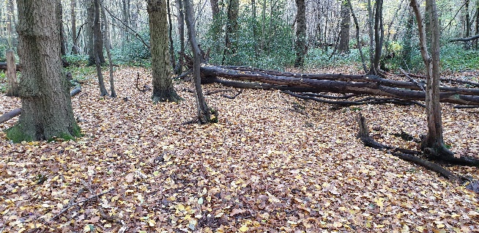
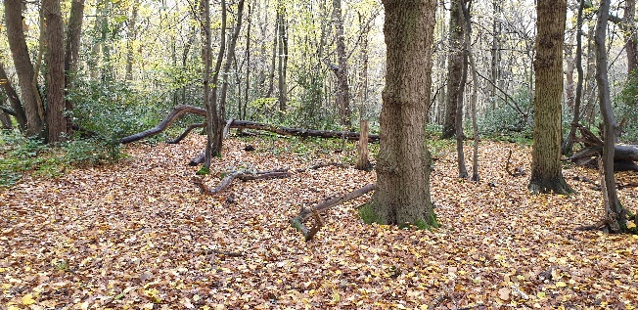
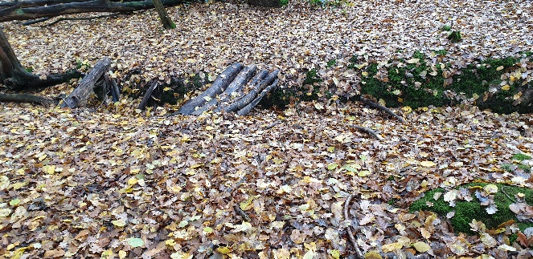
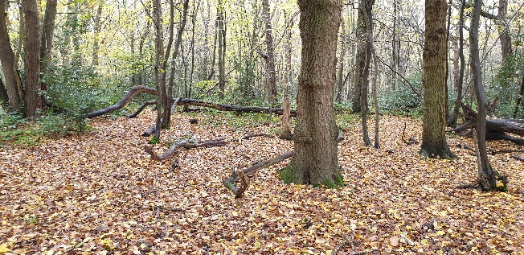
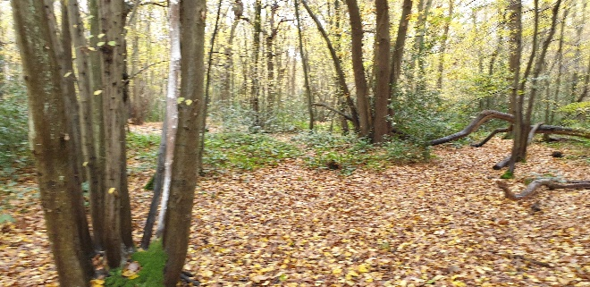

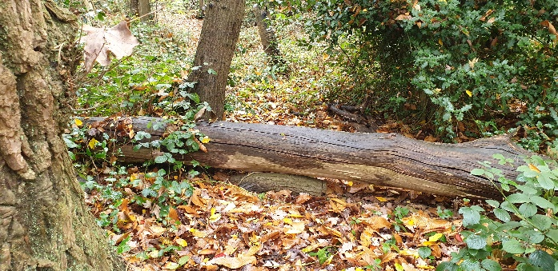
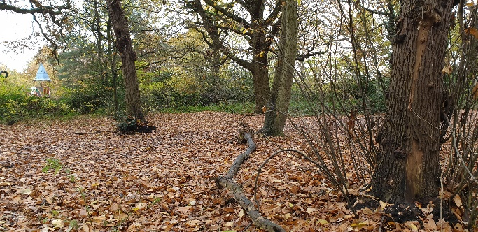
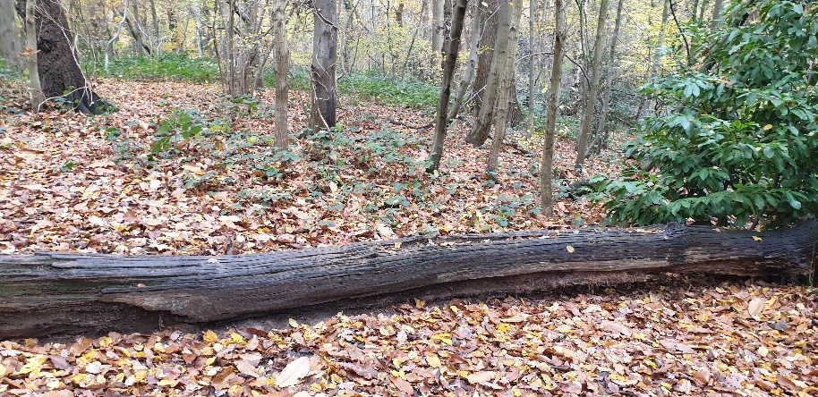
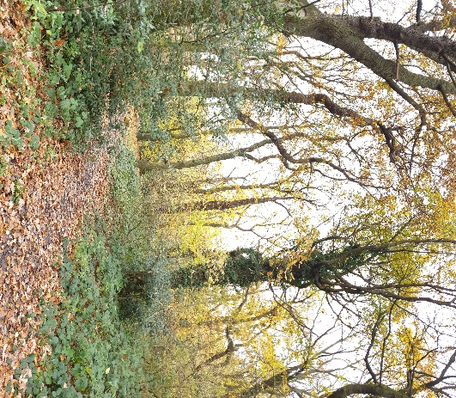
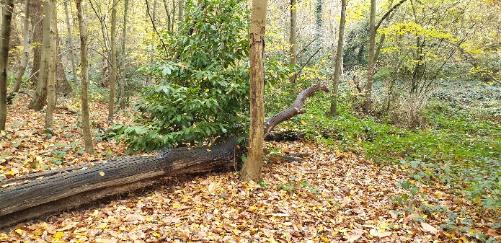
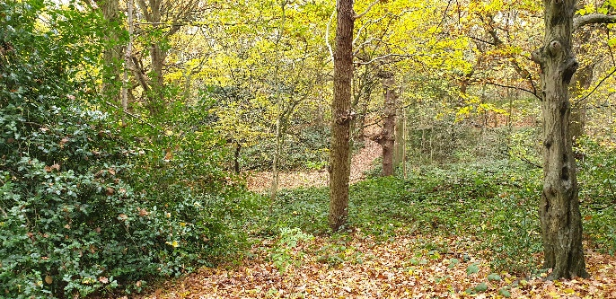

Test Footage Link - https://youtu.be/hviPpJpI6hQ

