Art of the Title Lesson 1

This week I was set the tasking of creating a similar sequence to the Harry Potter opening, although this would not be exact due to my own personal skill set with Adobe After Effects. The Harry Potter series started off life in a cafeteria as J.KRowling wrote down a piece of fiction that would storm the world, finding its way to the big screen in the early 2000’s and with this came its iconic title sequences. These have changed a lot of the ten years that the films have been around, I would be creating the later version of this intro animation.

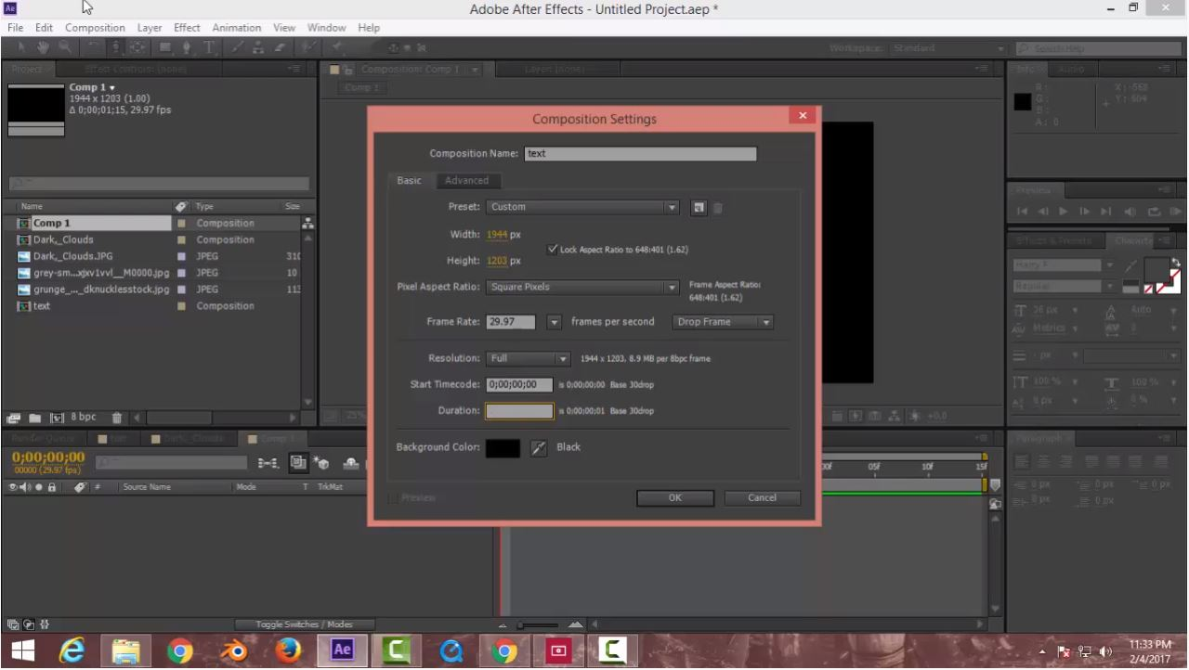
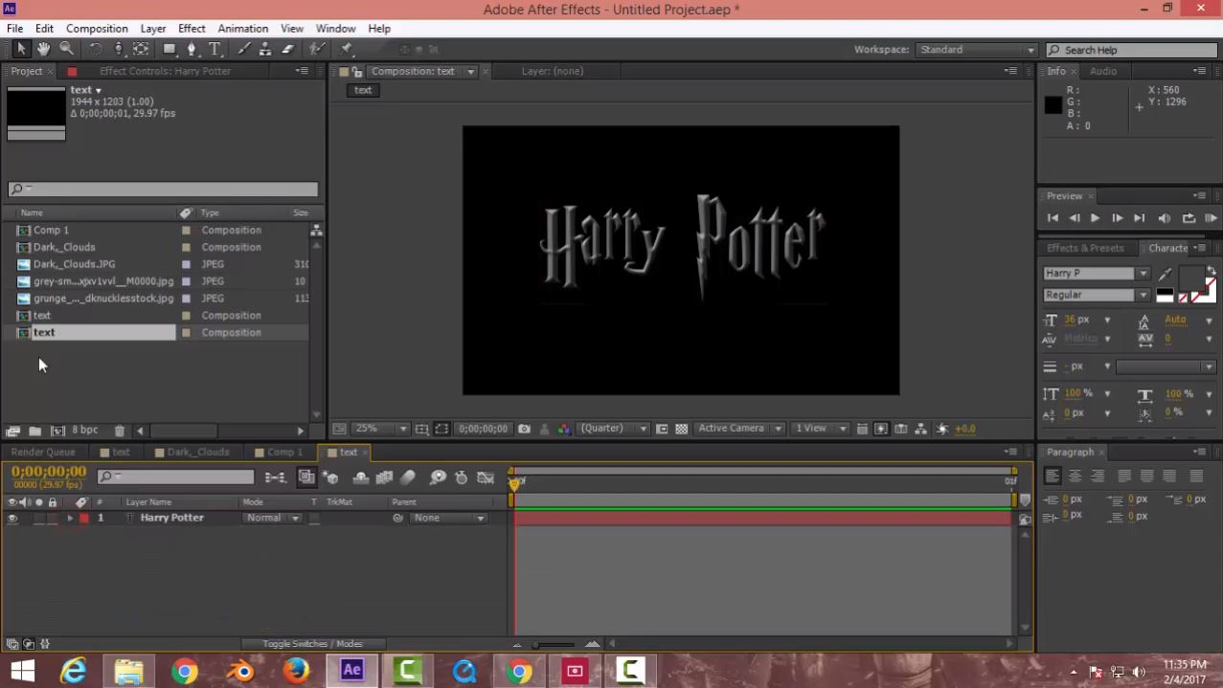
To begin I would create the words for the Harry Potter, this would be on a separate composition with a size of 1800 x 3000 and a duration of 0:00:00:01. This will form the basis of the text, allowing it to be manoeuvred around the main composition far easier. I found this relatively easy and it did not trouble me much compared to the rest of the process.

I then rendered this text and moved onto the next composition. This next composition would be the regularly used 1920 x 1080 HD with a duration of 0:00:00:10 seconds, although this would soon show to be rather difficult and take around two/three hours to complete this whole process.

I would quickly refresh myself on how to use keyframes and place a 35mm camera with a null object to control the movement of the words Harry Potter (although this would not actually be moving, it would be the camera that moved to create the illusion of movement). I then keyframed the Null object on the Z-axis of the ten second duration using the parent command.

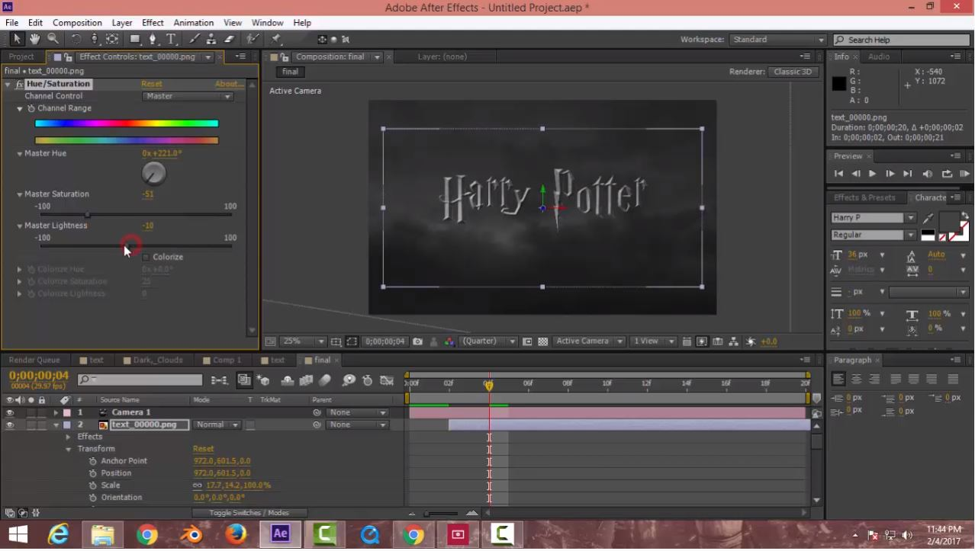
Moving on I would stylise the text to create a more Harry Potter feel, I did this using the Emboss and Bevel effects respectively, changing the techniques used to chisel hard and eventually setting the effects size to 150. Finally I added a grunge image whilst changing the tack mode to Alpha Matte and the compositions mode to Multiply, this allowed me to apply the grunge image to the text.

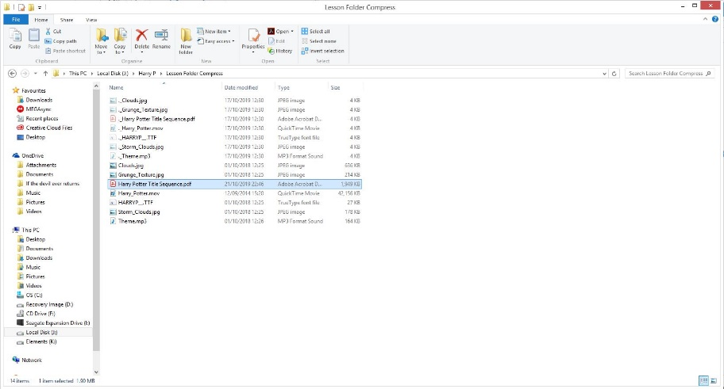
The final stage of this was to add the clouds to the sequence, a relatively easy segment of this exercise although the this was where I discovered the pen tool. This was not as hard as I thought it would be, although I was only drawing out rough etchings of clouds for the Harry Potter logo to fly past. This was completed also by changing the hue and saturation of the images.

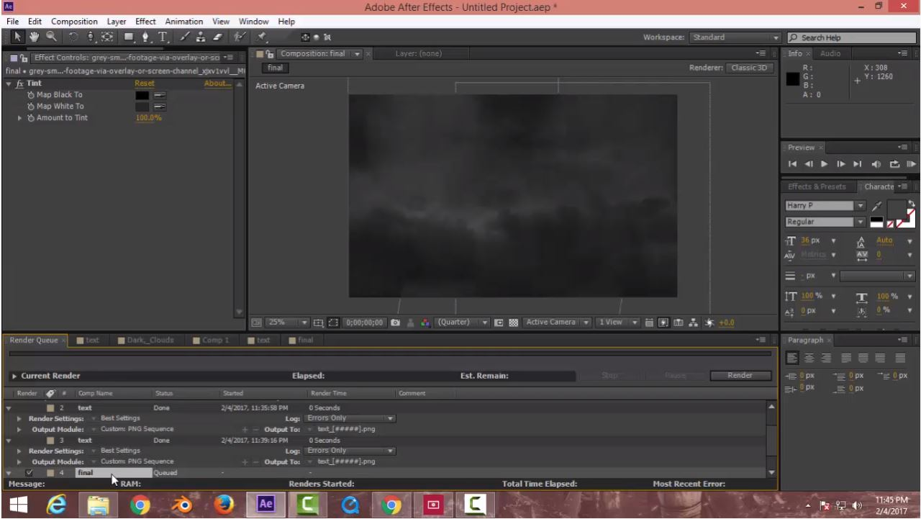
Using the 3D option I was able to place the clouds slightly in front of each other again, adding to the illusion of movement.

Modes of Persuasion:

Ethos: Harry Potter is born from the imagination of a best selling author and helped launch her career, the film relay on this already pre existing fan base to build its own, as those cast in the films gained fame they too would bring their own fans as well as those that the film would eventually bring in.

Pathos: The films change their Pacing and their tone as time goes on, this is to keep up with an aging audience much in the same way the books did, this allows the audience to remain interested as they grow older and avoids franchise fatigue.

Logos: The Logo would follow the Pathos closely as a logo must always fit with the tone of a film or television show.

Reflection:

What Happened: In this lesson I was able to recreate the Harry Potter title sequence.

Feelings: I only have basic skills in Adobe After Effects and can find myself completely lost when in the program with little to no motivation to hop in and use it as it is not an area of film I can find myself firmly attached to when compared to writing a screen-play or being on set in the director’s chair.

What was good bad: I was able to create a convincing title sequence although it did not fit the same quality as the film I have since followed this up by searching tutorials on YouTube, looking at alternate ways to create the sequence allowing me to expand my knowledge.

Analysis: I now have a better understanding of Adobe After Effects although still incredibly limited I hope to expand this and allow myself to apply what I learn to the Films/Television shows I create.

Action Plan: As stated earlier I have begun looking at tutorials on YouTube to expand my knowledge.

The Finished Sequence: https://youtu.be/Egc7le7C--A

